- Copy this DC Health Check to DC or AD server and open the script for All Certificates (DCHealthCheck.ps1) and fallow these steps:1- search to $smtpsetting, 2- write email address, 3- change email name,4- Write name or IP for the exchange server.
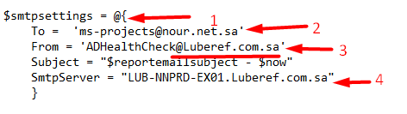
- Go to the exchange servers, open Task Scheduler, right-click on the Task Scheduler Library, and click import Task.
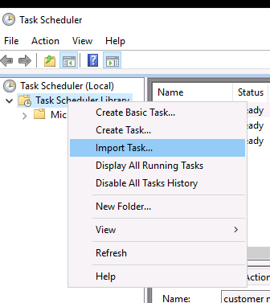

- Will open a new window and choose the script.
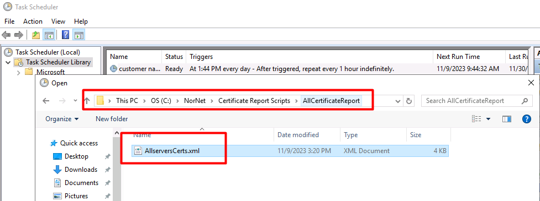

- Will open new window, click on the change User or Group and enter the Service Account

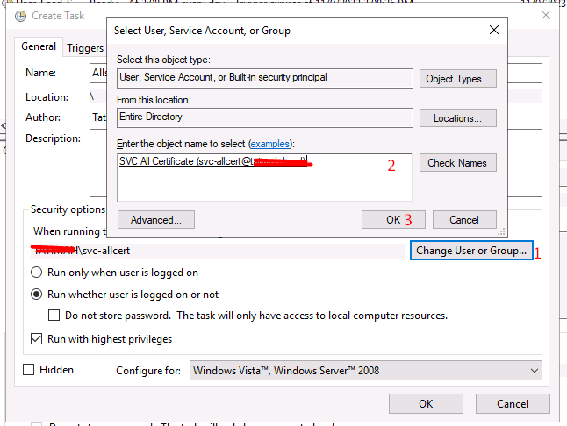
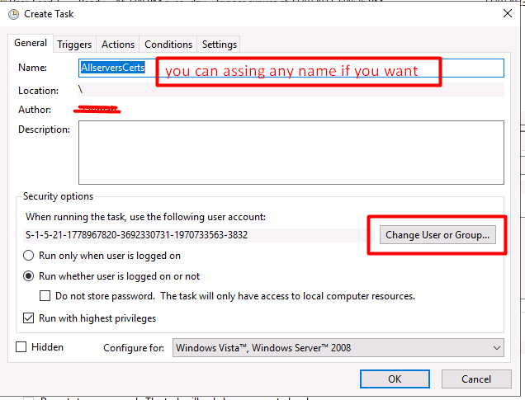

- Triggers, create as per the screenshot.
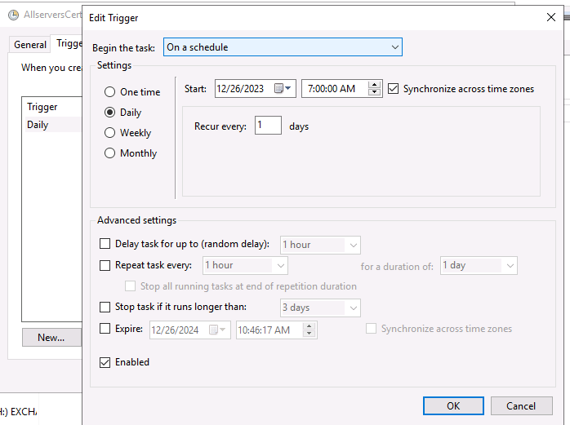
- Click on the Action and Edit and enter the below pass (before making sure the below pass is in the same location).
- 9, 1: Make sure this pass and write powershell.exe -c ".
- 9, 2: -command 'C:\Program Files\Microsoft\Exchange Server\V15\bin\RemoteExchange.ps1'; Connect-ExchangeServer -auto; "C:\Nournet\AllCertificateReport\AllCertificateReport.ps1" -Send-MailMessage
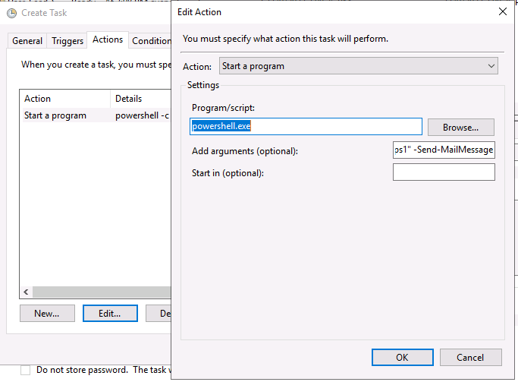

- Defiled.
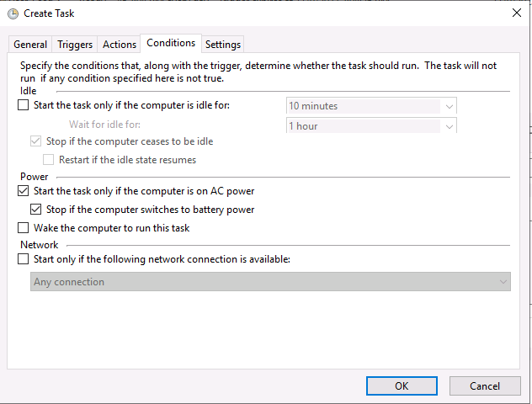

- Defiled.
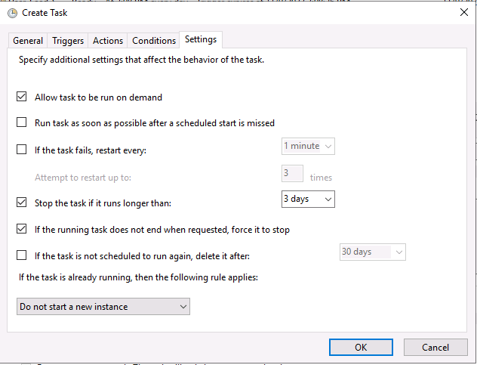

- Once you click OK will see message enter username and password for service account.
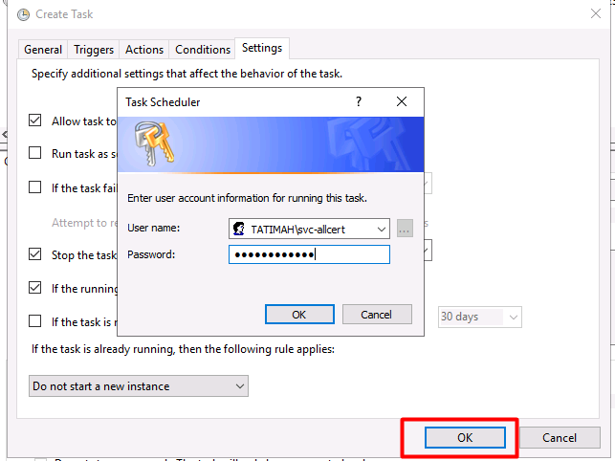
- Note: if see the below message check the service account add on the Log on as batch or not.
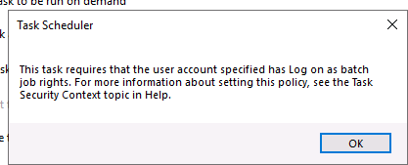
- Run this script.
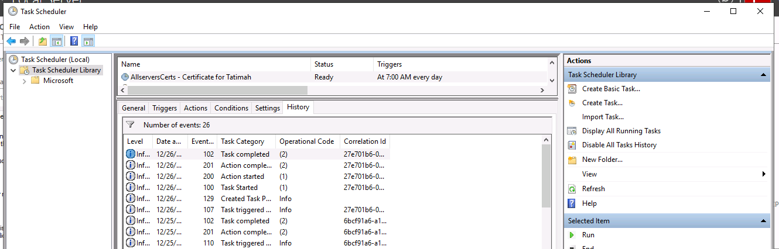
C:>.\DCHealthCheck.ps1 -domainName tatimah.local -SendEmail

C:\NorNet\DCHealthCheck> .\DCHealthCheck.ps1 -ReportFile
